Academic Continuity During COVID-19 and Work-Integrated Learning

Work-integrated learning (WIL) builds on the pedagogy behind experiential learning and works to provide students meaningful experience and reflection opportunities to aid in their transition from college to the workplace. In our current situation, where placements with employers may not be possible as designed, taking a flexible approach that focuses on the goals of experiential learning and the specific WIL experience will help to inform the best option for each experience.
Note: A continuity plan for co-op work placements has already been created, so this document focuses on other types of WIL.

Focusing on Flexibility
Where possible focus on whether the goals of the experience have been/can be achieved rather than focusing on the components of the specific WIL experience. For example:
- Can the goals be achieved within fewer hours?
- Can some flexibility be added to start and end dates?
- Could a placement or project be completed virtually?
- Can the goals of the WIL experience be achieved using a hybrid approach with some hours being completed at the workplace and some hours being delivered online?
- Could some students who have experience in the area complete the WIL requirement using Prior Learning Assessment and Recognition (PLAR)?
- If engaging employers or clients is not possible, could the placement or project be completed through a simulation?

Continuity Options for WIL

WIL Continuity – Decision Tree

Where possible, it is preferable to keep WIL opportunities as close to what was designed/advertised as possible. However, in recognition that it might not be possible to do so, the following decision tree may help you to determine which options should be considered first.

Considerations:

In selecting an option that works for each program, you should consider the following:
- Does the program have an accreditation process? If so, ensure any changes to WIL hours do not impact accreditation.
- Could a postponed WIL experience impact study and/or co-op internship permits for international students, i.e. will it alter break terms or lengthen the program? If so, reach out to the IEC for guidance
- Is the WIL experience a pre-requisite for any subsequent courses? If so, consider scheduling and curriculum implications.
- Will there be enough placements/projects available in subsequent terms if two cohorts are participating in WIL experiences at the same time?
- Are there any security or privacy concerns that should be considered with a modified and/or virtual delivery method?

Thinking Outside of the Box

Facilitating WIL experiences during COVID – 19 may require creativity as well as flexibility. Our own experiences over the last three weeks have shown that many things can be conducted virtually. A few suggestions of how to adapt WIL to this situation are as follows:
- Consider companies that are doing well or need extra help during this time, e.g. Food Box delivery companies, laboratories and public health campaigns.
- Could face-to-face activities can be delivered virtually, i.e. virtual circle time for young children, or virtual fitness classes or coaching?
- Could event-based WIL be planned and delivered virtually?
- Consider how students can help struggling small businesses using their training and skills, e.g. social media marketing plans, multimedia design, etc.
- Consider using a tool such as Riipen to help engage employers and facilitate virtual placements or project opportunities.

Difference Between WIL and Experiential Learning

Although work-integrated and experiential learning are often used interchangeably, there are distinct differences with experiential learning representing a boarder subset of learning experiences that include simulated activities and projects and work-integrated learning referring to more specific experience with employers and/or clients. The diagram below depicts the relationship between experiential and work-integrated learning. Although Algonquin has focused on ensuring students have at least one WIL experience, it may be necessary or preferable in the spring/summer term to consider broader experiential learning opportunities for some or all students.

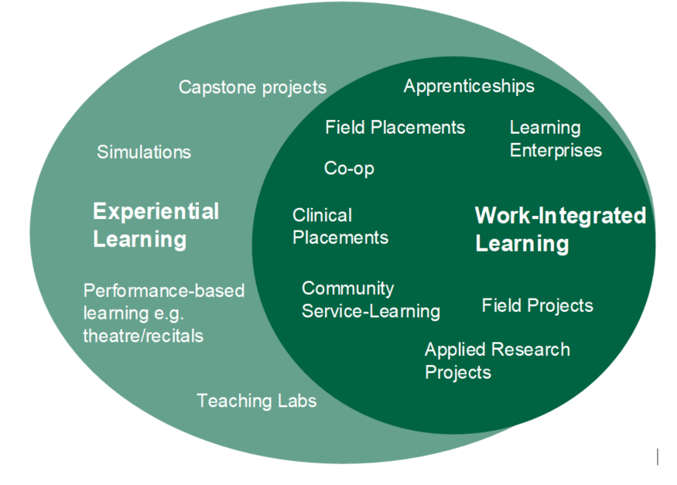

Experiential Learning Checklist

When altering WIL experiences, it is important to ensure the new offering continues to meet the six elements of the MTCU’s experiential learning checklist:

- The student is in a workplace or simulated workplace.
- The student is exposed to authentic demands that improve their job-ready skills, interpersonal skills, and transition to the workforce.
- The experience is structured with purposeful and meaningful activities.
- The student applies university or college program knowledge and/or essential employability skills.
- The experience includes student self-assessment and evaluation of the student's performance and learning outcomes by the employer and/or university/college.
- The experience counts towards course credit or credential completion OR is formally recognized by the college or university as meeting the five criteria above.

Support for Virtual WIL Projects and Internships through Riipen

If a program requires assistance to engage employers or community partners, you may want to consider Riipen. Riipen offers support for virtual WIL opportunities such as internships and field projects. Riipen helps both to find employer partners, and to provide a platform on which students can interact with employer partners.

Riipen has indicated that they will make their service available free of charge for the Spring/Summer term. If you are interested in more information about Riipen, please reach out to Jessica at brownj1@algonquincollege.com to put you in touch with a Riipen representative.

Additional Resources

- Our Algonquin College experiential learning website has additional information about different kinds of WIL and experiential learning and best practices on how to design these experiences.
- Algonquin’s WIL Typology defines different types of WIL.

If you have any additional questions or would like to meet to discuss possible solutions, please contact Jessica Brown at brownj1@algonquincollege.com.

-With thanks to George Brown College for sharing their resource that helped to inform this document-

