Extracting a list of Course Outlines (by Department) and their Current Status in Course Outline Mapping and Management System (COMMS 3.0)

On the main Dashboard, type your department code in the search bar at the top right-hand corner:

Hit enter
Click on ‘type’ and select ‘Department’ from the drop-down menu:
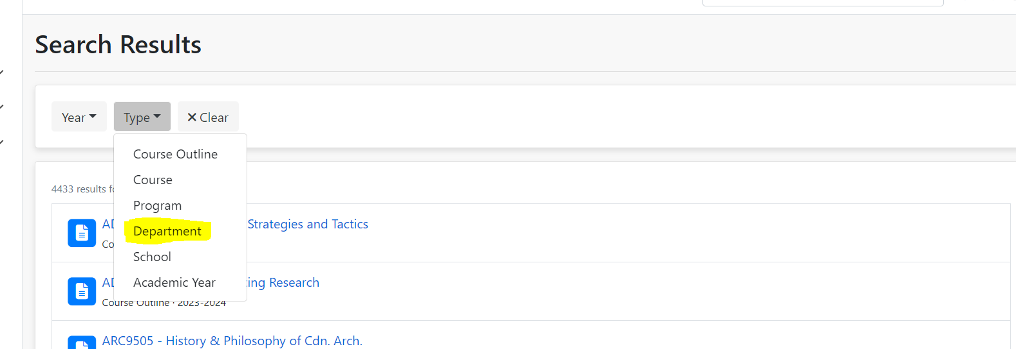

Click on the department name, making sure to select the one attached to the current year:
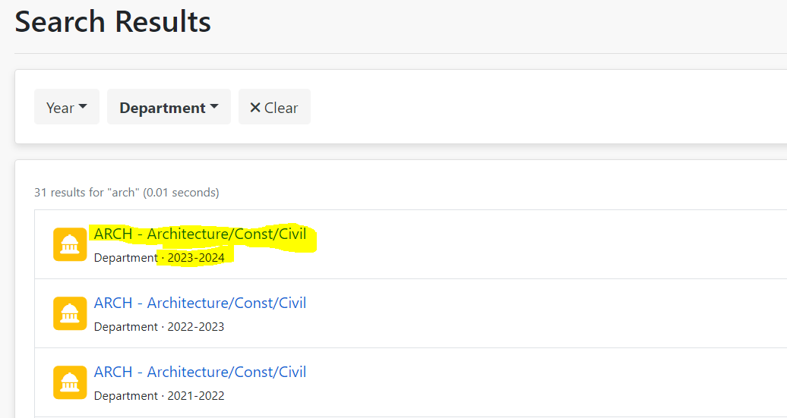

Under the Course Outlines section of the page, you’ll see the results. These can be filtered by term, using the Term filter drop-down:
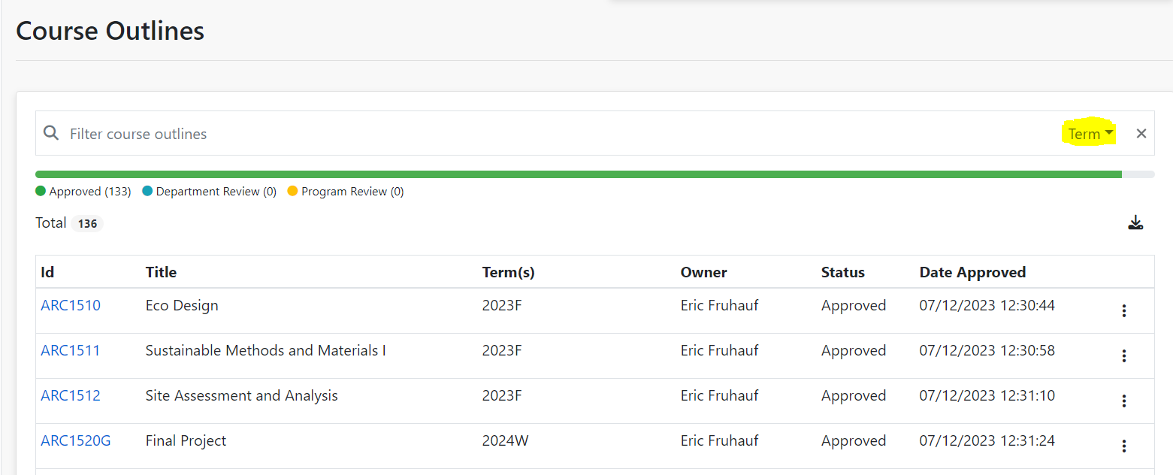

Additionally, you can download the entire list to a CSV file and sort or filter based on your needs. To download, click on the download button:
