Email Signature Setup

  - The following should done within Algonquin College’s most current verison of Microsoft Outlook for best results.
Open new email message
Click signature icon then “Edit Signatures”
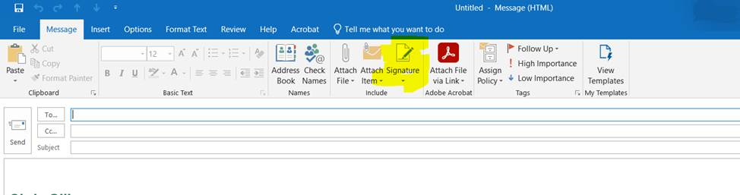

In popup window, select “New” (or ‘+’ on Mac)
Copy and paste signature of your choice into text field
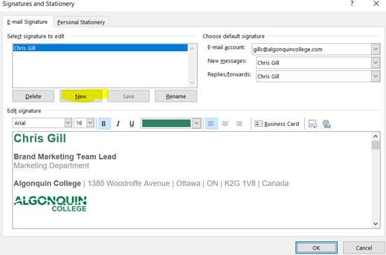

Name the new signature as desired. Then you need to copy the desired signature from the word doc available on the marketing site.

From there, right click in the edit signatures section and under paste options select keep source formatting: Edit as required
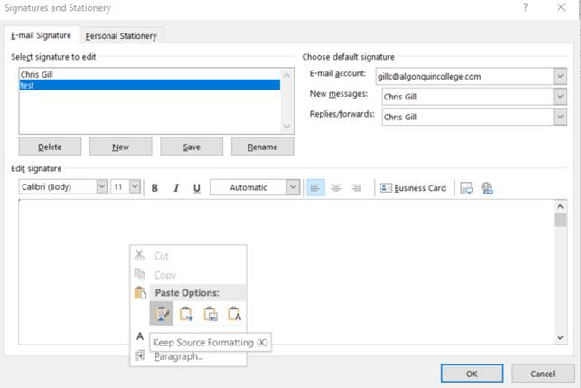

Email Disclaimer
Policy IT01 under Section 2.7(12)
Employees and contractors with College provided email accounts must use the following automatically generated email disclaimer at the bottom of all emails:
This email is intended solely for the addressee(s) and is Confidential. If you received this in error, any disclosure, copying, or distribution is prohibited. Please reply and inform the sender and delete all copies. Thank you.

No Logo Options
Copy and paste email signatures shouldn’t include image files. While flexibility is provided, variations should have no less information than in option #1 and no more than option #5.
1.
Firstname Lastname
Title
Primary Unit Name, Secondary Unit Name (if applicable)
T 613.727.4723 x1234
Algonquin College

This email is intended solely for the addressee(s) and is Confidential. If you received this in error, any disclosure, copying, or distribution is prohibited. Please reply and inform the sender and delete all copies. Thank you.
2.
Firstname Lastname
Title
Primary Unit Name, Secondary Unit Name (if applicable)
T 613.727.4723 x1234
Algonquin College | 1385 Woodroffe Avenue | Ottawa | ON | K2G 1V8 | Canada

This email is intended solely for the addressee(s) and is Confidential. If you received this in error, any disclosure, copying, or distribution is prohibited. Please reply and inform the sender and delete all copies. Thank you.
3.
Firstname Lastname
Title
Primary Unit Name, Secondary Unit Name (if applicable)
T 613.727.4723 x1234
Algonquin College

Our Mission: To transform hopes and dreams into lifelong success

This email is intended solely for the addressee(s) and is Confidential. If you received this in error, any disclosure, copying, or distribution is prohibited. Please reply and inform the sender and delete all copies. Thank you.
4.
Firstname Lastname
Title
Primary Unit Name, Secondary Unit Name (if applicable)
T 613.727.4723 x1234
Algonquin College | 1385 Woodroffe Avenue | Ottawa | ON | K2G 1V8 | Canada

algonquincollege.com

Our Mission: To transform hopes and dreams into lifelong success

This email is intended solely for the addressee(s) and is Confidential. If you received this in error, any disclosure, copying, or distribution is prohibited. Please reply and inform the sender and delete all copies. Thank you.

5.
Firstname Lastname
Title
Primary Unit Name, Secondary Unit Name (if applicable)
Room/Office A000, Building Name
T 613.727.4723 x1234
C 613.555.5555
Algonquin College | 1385 Woodroffe Avenue | Ottawa | ON | K2G 1V8 | Canada

LinkedIn Twitter Website

Our Mission: To transform hopes and dreams into lifelong success

This email is intended solely for the addressee(s) and is Confidential. If you received this in error, any disclosure, copying, or distribution is prohibited. Please reply and inform the sender and delete all copies. Thank you.

Logo Versions
While copy and paste email signatures shouldn’t include image files, the option has been provided per popular demand. While flexibility is provided, variations should have no less information than in option #1 and no more than option #4.
1.
Firstname Lastname
Title
Primary Unit Name, Secondary Unit Name (if applicable)
T 613.727.4723 x1234
Algonquin College | 1385 Woodroffe Avenue | Ottawa | ON | K2G 1V8 | Canada
This email is intended solely for the addressee(s) and is Confidential. If you received this in error, any disclosure, copying, or distribution is prohibited. Please reply and inform the sender and delete all copies. Thank you.
2.
Firstname Lastname
Title
Primary Unit Name, Secondary Unit Name (if applicable)
T 613.727.4723 x1234
Algonquin College | 1385 Woodroffe Avenue | Ottawa | ON | K2G 1V8 | Canada
Our Mission: To transform hopes and dreams into lifelong success
This email is intended solely for the addressee(s) and is Confidential. If you received this in error, any disclosure, copying, or distribution is prohibited. Please reply and inform the sender and delete all copies. Thank you.
3.
Firstname Lastname
Title
Primary Unit Name, Secondary Unit Name (if applicable)
T 613.727.4723 x1234
Algonquin College | 1385 Woodroffe Avenue | Ottawa | ON | K2G 1V8 | Canada

algonquincollege.com

Our Mission: To transform hopes and dreams into lifelong success
This email is intended solely for the addressee(s) and is Confidential. If you received this in error, any disclosure, copying, or distribution is prohibited. Please reply and inform the sender and delete all copies. Thank you.

4.
Firstname Lastname
Title
Primary Unit Name, Secondary Unit Name (if applicable)
Room/Office A000, Building Name
T 613.727.4723 x1234
C 613.555.5555
Algonquin College | 1385 Woodroffe Avenue | Ottawa | ON | K2G 1V8 | Canada

LinkedIn Twitter Website
Our Mission: To transform hopes and dreams into lifelong success

This email is intended solely for the addressee(s) and is Confidential. If you received this in error, any disclosure, copying, or distribution is prohibited. Please reply and inform the sender and delete all copies. Thank you.

Logo Versions (Pembroke)
While copy and paste email signatures shouldn’t include image files, the option has been provided per popular demand. While flexibility is provided, variations should have no less information than in option #1 and no more than option #4.
1.
Firstname Lastname
Title
Primary Unit Name, Secondary Unit Name (if applicable)
T 613.727.4723 x1234
Algonquin College | 1385 Woodroffe Avenue | Ottawa | ON | K2G 1V8 | Canada
This email is intended solely for the addressee(s) and is Confidential. If you received this in error, any disclosure, copying, or distribution is prohibited. Please reply and inform the sender and delete all copies. Thank you.
2.
Firstname Lastname
Title
Primary Unit Name, Secondary Unit Name (if applicable)
T 613.727.4723 x1234
Algonquin College | 1385 Woodroffe Avenue | Ottawa | ON | K2G 1V8 | Canada
Our Mission: To transform hopes and dreams into lifelong success
This email is intended solely for the addressee(s) and is Confidential. If you received this in error, any disclosure, copying, or distribution is prohibited. Please reply and inform the sender and delete all copies. Thank you.

3.
Firstname Lastname
Title
Primary Unit Name, Secondary Unit Name (if applicable)
T 613.727.4723 x1234
Algonquin College | 1385 Woodroffe Avenue | Ottawa | ON | K2G 1V8 | Canada

algonquincollege.com

Our Mission: To transform hopes and dreams into lifelong success

This email is intended solely for the addressee(s) and is Confidential. If you received this in error, any disclosure, copying, or distribution is prohibited. Please reply and inform the sender and delete all copies. Thank you.
4.
Firstname Lastname

Title
Primary Unit Name, Secondary Unit Name (if applicable)
Room/Office A000, Building Name
T 613.727.4723 x1234
C 613.555.5555
Algonquin College | 1385 Woodroffe Avenue | Ottawa | ON | K2G 1V8 | Canada

LinkedIn Twitter Website

Our Mission: To transform hopes and dreams into lifelong success
This email is intended solely for the addressee(s) and is Confidential. If you received this in error, any disclosure, copying, or distribution is prohibited. Please reply and inform the sender and delete all copies. Thank you.

Logo Versions (Perth)
While copy and paste email signatures shouldn’t include image files, the option has been provided per popular demand. While flexibility is provided, variations should have no less information than in option #1 and no more than option #4.
1.
Firstname Lastname
Title
Primary Unit Name, Secondary Unit Name (if applicable)
T 613.727.4723 x1234
Algonquin College | 1385 Woodroffe Avenue | Ottawa | ON | K2G 1V8 | Canada
This email is intended solely for the addressee(s) and is Confidential. If you received this in error, any disclosure, copying, or distribution is prohibited. Please reply and inform the sender and delete all copies. Thank you.
2.
Firstname Lastname
Title
Primary Unit Name, Secondary Unit Name (if applicable)
T 613.727.4723 x1234
Algonquin College | 1385 Woodroffe Avenue | Ottawa | ON | K2G 1V8 | Canada
Our Mission: To transform hopes and dreams into lifelong success
This email is intended solely for the addressee(s) and is Confidential. If you received this in error, any disclosure, copying, or distribution is prohibited. Please reply and inform the sender and delete all copies. Thank you.
3.
Firstname Lastname
Title
Primary Unit Name, Secondary Unit Name (if applicable)
T 613.727.4723 x1234
Algonquin College | 1385 Woodroffe Avenue | Ottawa | ON | K2G 1V8 | Canada

algonquincollege.com

Our Mission: To transform hopes and dreams into lifelong success
This email is intended solely for the addressee(s) and is Confidential. If you received this in error, any disclosure, copying, or distribution is prohibited. Please reply and inform the sender and delete all copies. Thank you.
4.
Firstname Lastname
Title
Primary Unit Name, Secondary Unit Name (if applicable)
Room/Office A000, Building Name
T 613.727.4723 x1234
C 613.555.5555
Algonquin College | 1385 Woodroffe Avenue | Ottawa | ON | K2G 1V8 | Canada

LinkedIn Twitter Website

Our Mission: To transform hopes and dreams into lifelong success

This email is intended solely for the addressee(s) and is Confidential. If you received this in error, any disclosure, copying, or distribution is prohibited. Please reply and inform the sender and delete all copies. Thank you.

Logo Versions (Online)
While copy and paste email signatures shouldn’t include image files, the option has been provided per popular demand. While flexibility is provided, variations should have no less information than in option #1 and no more than option #4.
1.
Firstname Lastname
Title
Primary Unit Name, Secondary Unit Name (if applicable)
T 613.727.4723 x1234
Algonquin College | 1385 Woodroffe Avenue | Ottawa | ON | K2G 1V8 | Canada
This email is intended solely for the addressee(s) and is Confidential. If you received this in error, any disclosure, copying, or distribution is prohibited. Please reply and inform the sender and delete all copies. Thank you.
2.
Firstname Lastname
Title
Primary Unit Name, Secondary Unit Name (if applicable)
T 613.727.4723 x1234
Algonquin College | 1385 Woodroffe Avenue | Ottawa | ON | K2G 1V8 | Canada
Our Mission: To transform hopes and dreams into lifelong success
This email is intended solely for the addressee(s) and is Confidential. If you received this in error, any disclosure, copying, or distribution is prohibited. Please reply and inform the sender and delete all copies. Thank you.
3.
Firstname Lastname
Title
Primary Unit Name, Secondary Unit Name (if applicable)
T 613.727.4723 x1234
Algonquin College | 1385 Woodroffe Avenue | Ottawa | ON | K2G 1V8 | Canada

algonquincollege.com

Our Mission: To transform hopes and dreams into lifelong success

This email is intended solely for the addressee(s) and is Confidential. If you received this in error, any disclosure, copying, or distribution is prohibited. Please reply and inform the sender and delete all copies. Thank you.
4.
Firstname Lastname
Title
Primary Unit Name, Secondary Unit Name (if applicable)
Room/Office A000, Building Name
T 613.727.4723 x1234
C 613.555.5555
Algonquin College | 1385 Woodroffe Avenue | Ottawa | ON | K2G 1V8 | Canada

LinkedIn Twitter Website

Our Mission: To transform hopes and dreams into lifelong success
This email is intended solely for the addressee(s) and is Confidential. If you received this in error, any disclosure, copying, or distribution is prohibited. Please reply and inform the sender and delete all copies. Thank you.

Logo Versions (All Domestic Campuses)
While copy and paste email signatures shouldn’t include image files, the option has been provided per popular demand. While flexibility is provided, variations should have no less information than in option #1 and no more than option #4.
1.
Firstname Lastname
Title
Primary Unit Name, Secondary Unit Name (if applicable)
T 613.727.4723 x1234
Algonquin College | 1385 Woodroffe Avenue | Ottawa | ON | K2G 1V8 | Canada
This email is intended solely for the addressee(s) and is Confidential. If you received this in error, any disclosure, copying, or distribution is prohibited. Please reply and inform the sender and delete all copies. Thank you.
2.
Firstname Lastname
Title
Primary Unit Name, Secondary Unit Name (if applicable)
T 613.727.4723 x1234
Algonquin College | 1385 Woodroffe Avenue | Ottawa | ON | K2G 1V8 | Canada
Our Mission: To transform hopes and dreams into lifelong success
This email is intended solely for the addressee(s) and is Confidential. If you received this in error, any disclosure, copying, or distribution is prohibited. Please reply and inform the sender and delete all copies. Thank you.
3.
Firstname Lastname
Title
Primary Unit Name, Secondary Unit Name (if applicable)
T 613.727.4723 x1234
Algonquin College | 1385 Woodroffe Avenue | Ottawa | ON | K2G 1V8 | Canada

algonquincollege.com

Our Mission: To transform hopes and dreams into lifelong success

This email is intended solely for the addressee(s) and is Confidential. If you received this in error, any disclosure, copying, or distribution is prohibited. Please reply and inform the sender and delete all copies. Thank you.
4.
Firstname Lastname
Title
Primary Unit Name, Secondary Unit Name (if applicable)
Room/Office A000, Building Name
T 613.727.4723 x1234
C 613.555.5555
Algonquin College | 1385 Woodroffe Avenue | Ottawa | ON | K2G 1V8 | Canada

LinkedIn Twitter Website

Our Mission: To transform hopes and dreams into lifelong success
This email is intended solely for the addressee(s) and is Confidential. If you received this in error, any disclosure, copying, or distribution is prohibited. Please reply and inform the sender and delete all copies. Thank you.

